Preliminary Progress Report
  - Lakshay Agarwal – 2025MEM2628

Design of a Four-Bar Linkage from Hand-Drawn Approximate Coupler Trajectory Using Data-Driven Methods

1. Introduction
Designing a planar four-bar linkage to track a specific path is a classic challenge in mechanical engineering. Traditionally, this is achieved through complicated graphical or analytical methods which have limited accuracy. However, with deep learning, it's now feasible to generate mechanical geometries directly from desired output paths. This project connects machine learning and mechanical design to build a system that can automatically calculate the dimensions of a four-bar linkage based entirely on a simple hand-drawn spatial trajectory. The intent of enabling hand drawn path input is to allow the designers the flexibility to ideate and get quick results, which can be extended to full design methodology that enables to design physical linkages.

2. Literature Review
The approach to synthesizing mechanisms has been changing largely due to data-driven learning techniques. Röder et al. [1] showed that an automated framework could effectively reconstruct four-bar mechanisms straight from hand-drawn trajectories. Their work proved that deep learning and optimization can successfully overcome the tricky, non-linear mathematics that relate the linkage dimensions to the path they output.
For our core machine learning methodology, we're heavily utilizing the concepts from both Bishop et al. [2] and Hermann et al. [3]. Bishop et al. [2] discusses how supervised training frameworks acting on objective loss functions, like Mean Squared Error (MSE), provide excellent gradient-based optimization for highly non-linear pattern recognition tasks, which perfectly applies to our inverse kinematics formulation. Furthermore, Herrmann et al. [3] provides a solid foundation on applying deep learning methodologies directly to computational mechanics. Together, these references validate our decision to replace analytical problem-solving with a neural network architecture framework.

3. Aim
To construct a deep learning model capable of designing a complete mathematical four-bar linkage that can approximate and follow a desired hand-drawn user path.

4. Objective
- To programmatically define the forward kinematics of a standard four-bar linkage.
- To generate a valid synthetic dataset of linkage dimensions and their resulting coupler path shapes.
- To design and train a supervised neural network that accurately works backwards: mapping continuous output paths back to their originating physical linkage parameters.

5. Methodology
Instead of tackling absolute lengths, the model will output normalized length ratios to avoid getting confused by overlapping scaled solutions.

5.1-Dimensional Normalization
The core link lengths $(a,b,c,d)$, alongside the coupler offset dimensions, are all presented as ratios relative to the longest link in the assembly. This guarantees the model learns scale-invariant geometric relationships. Say, the link length $c$ is the longest among all the dimensions, so the dimensions used for the model will be of the following format.
Actual dimension | Normalized dimension
$$a$$ | $$a/c$$
$$b$$ | $$b/c$$
$$c$$ | $$1$$
$$d$$ | $$d/c$$
Table 1- Normalization of linkage dimensions

5.2-Synthetic Data Generation Pipeline
A forward kinematics script is used to algorithmically produce data. Random linkages are generated but then strictly filtered through Grashof's condition. This ensures that only functional, continuous mechanisms (which don't physically lock up) survive. The $(X,Y)$ coordinate sequence of the resultant coupler path is computed analytically.

5.3-Fourier Extraction
Since giving raw coordinates as input to the model would be inefficient by increasing the input vector dimension, and also having complexities relating to noise and arbitrary densities, the path is converted to the frequency spectrum. The $(X,Y)$ sequence is passed into a Fourier transform, and the lowest 15 complex Fourier Descriptors are flattened into a concise 30-element feature vector, 15 for $X$ coordinate, and 15 for $Y$ coordinate. This acts as clean input data for the model.

5.4-Neural Network Architecture
The main architecture is a Multi-Layer Perceptron (MLP) built in PyTorch. It takes the 30 Fourier Descriptor variables as input. From there, it flows through three hidden layers, each having 128 nodes with ReLU activations. Ultimately, the network outputs 6 numerical node values which correspond to the relative parameters needed to construct the final predicted linkage.

6. Progress Summary and Forward Plan
At this stage in the project, the foundational code is set up, and we've successfully validated both the data generation pipeline and the overall model training layout using a small preliminary dataset.

6.1 Work Completed So Far
- Kinematics Engine: The forward kinematics logic has been coded into Python (data_generation.py), complete with dynamic simulation loops and Grashof constraint validation to filter out non-viable designs.
- Data Transformation Tooling: The complex Fourier logic is written and working, seamlessly converting generated mathematical paths into the strict 30-element input array that PyTorch requires.
- Model Validation: Both the network layout (model.py) and training loop (train.py) have been built.
- Proof of Concept Training: A small test of 500 samples using the Adam Optimizer was run. Over 50 epochs, the network reliably forced the Mean Squared Error (MSE) down from approximately 12.6 to 0.31. This test critically proves that the data formatting methodology and the underlying neural network shape are fully capable of learning to map these non-linear mechanisms properly.
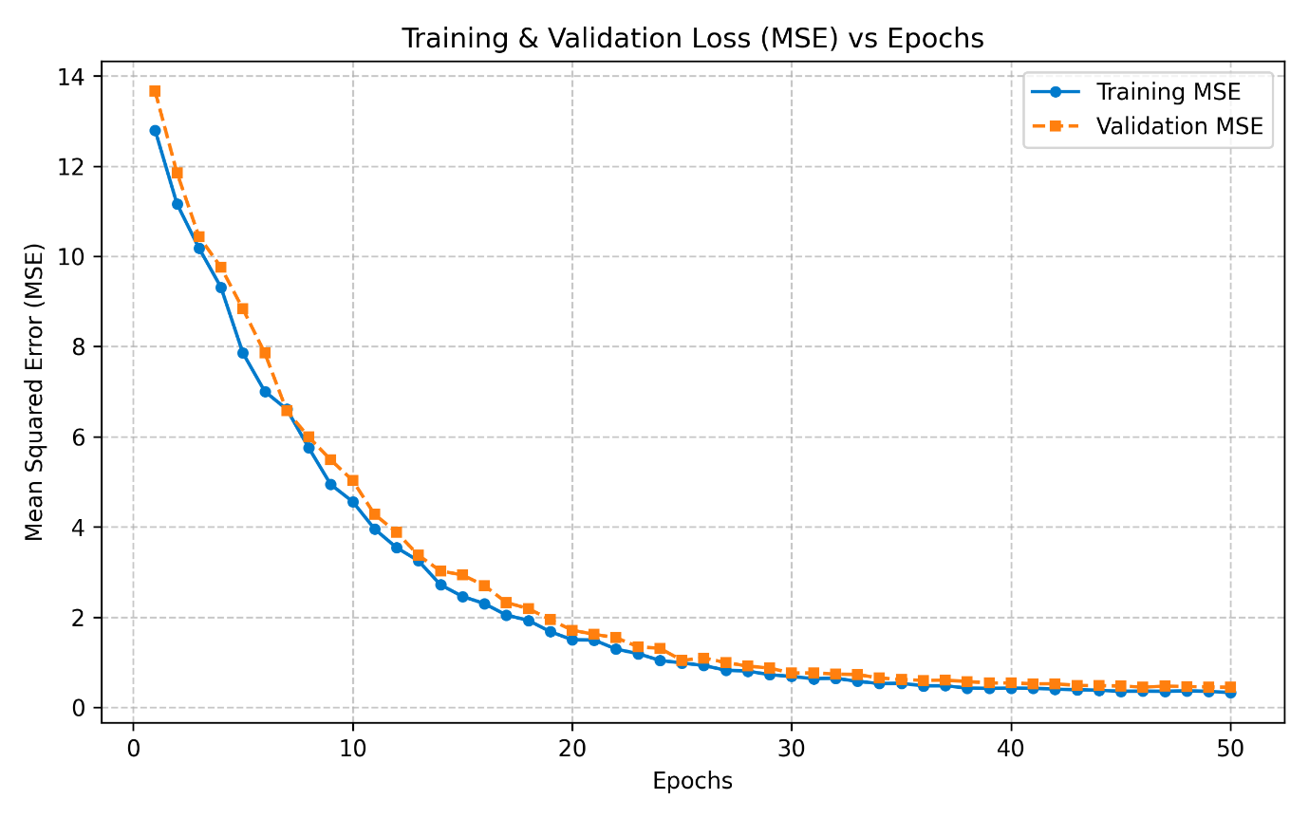
Figure 1- Training and Validation MSE reduction over 50 epochs with small synthesized dataset

6.2 Overall Architecture and Current Status
The following block diagram shown in __ outlines all the primary sub-parts of the planned architecture, highlighting what has been achieved so far and providing context for what remains.
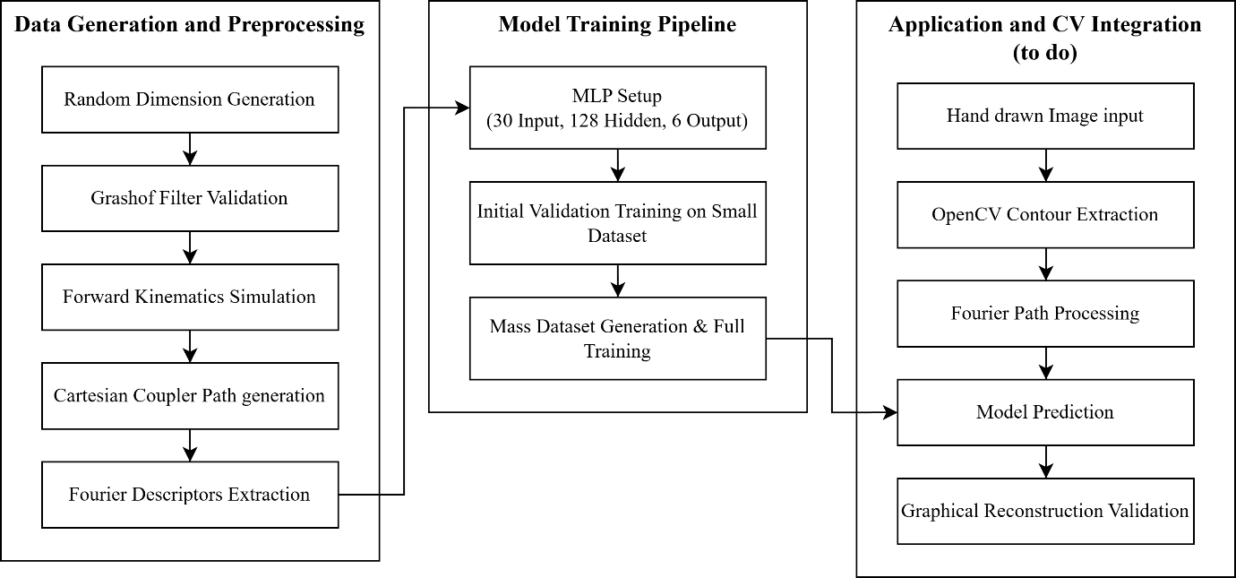
Figure 2- Model Architecture

6.3 What Needs to be Done Next
To conclude the final phases, these are our main remaining targets:
- Mass Dataset Training: Run the verified generation pipeline to construct a massive dataset, fully train the model on it to ensure it perfectly generalizes the inverse mapping math without underfitting.
- Machine Vision Integration Framework: Architect a script using OpenCV that can look at a hand-drawn PNG trace, extract the boundary coordinate data, and pipeline it straight toward our Fourier script for processing.
- Graphical Re-evaluation script: Develop a visual script to take the final outputs of the ML model and redraw the predicted mechanism, so we can benchmark and visually compare the network's prediction against the original raw visual input.
GitHub Repository: Automated-design-of-four-bar-linkage (https://github.com/LakshayAga/Automated-design-of-four-bar-linkage)

7. References
[1] B. Röder, S. Hajipour, H. Ebel, P. Eberhard, and D. Bestle, “Automated design of a four-bar mechanism starting from hand drawings of desired coupler trajectories and velocity profiles,” Mechanics Based Design of Structures and Machines, 2025, doi: 10.1080/15397734.2025.2543559.
[2] C. M. Bishop, Pattern Recognition and Machine Learning (Information Science and Statistics). Berlin, Heidelberg: Springer-Verlag, 2006.
[3] L. Herrmann, M. Jokeit, O. Weeger, and S. Kollmannsberger, “Deep Learning in Computational Mechanics,” Deep Learning in Computational Mechanics, 2025, doi: 10.1007/978-3-031-89529-6.

END OF REPORT – 06-04-2026

